**CENTRE FOR DEVELOPMENT OF ADVANCED COMPUTING**



**Advanced Computing Training School**

**Course Name:** PG- Diploma in Advanced Computing

**Batch:** SEP 2021

**Module Name:** WEB based java **Date: 11/01/2022 Student Name: _____________________________ Max Marks: 40 Marks**

**PRN No: ___________________________________ Duration: 2 Hours**

**______________________________________________________________________________________________________________________________________________________________**

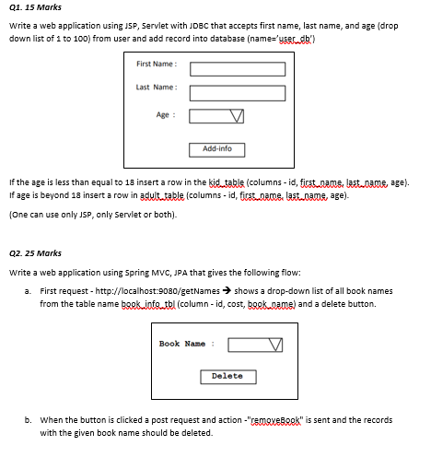

**Evaluation of Lab Exam should be based on the following criteria**

|  |  |  |  |
| --- | --- | --- | --- |
| **Criteria** | **Details** | **Max**  **Marks** | **Marks**  **Obtain** |
| **Algorithm** | **Documentation of Algorithm and Flowchart** | **2** |  |
| **Program adheres to the algorithm and flowchart** | **2** |  |
| **Efficiency** | **Program is using only the required number of variables**  **/conditions/loops/pointers etc and is optimal** | **2** |  |
| **Correctness** | **The program produces desired output for a given input** | **25**  **5** |  |
| **The program handles all valid and Invalid inputs** |  |
| **Software**  **Engineering**  **Principles** | **The program has meaning variable/function names** | **2** |  |
| **The program is commented properly (At least 20% of the**  **code should be commented)** | **2** |  |
|  | ***Total Marks*** | **40** |  |
| cccccccc |  |  |  |

_____________________ _________________________ __________________

**Signature of Student** **Signature of Evaluator** **Signature of Coordinator**

**Page 1 of 1**